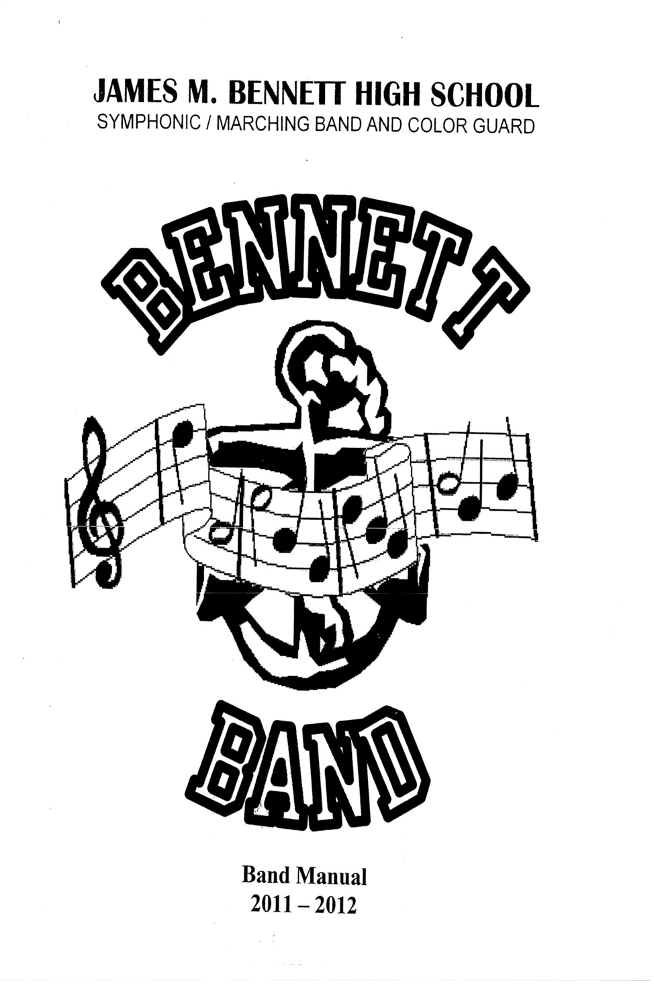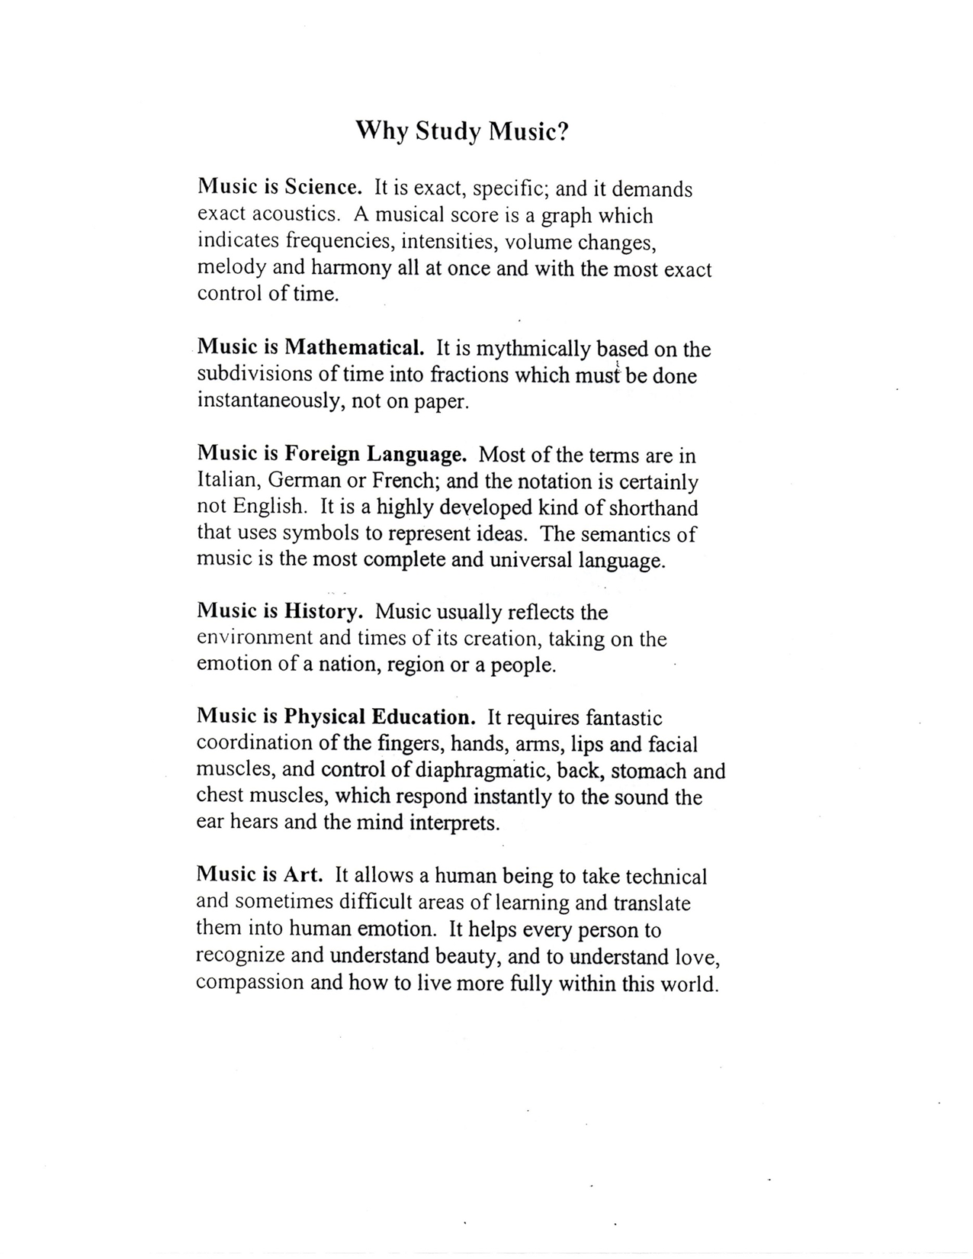
Band & Color Guard
Manual
2026 - 2027

James M. Bennett High School Bands 
Caroline Gilmore, Director School Phone: (410) 677-5141
Band Room: (410) 677-5292
300 East College Avenue Fax: (410) 677-5126
Salisbury, Maryland 21804 email: cgilmore@mywcps.org

June 8, 2026

Dear Band and Color Guard Families,

Congratulations and welcome to the James M. Bennett Marching Band & Guard Program. Your JMB student has successfully auditioned for membership in the Marching/Symphonic Band and Color Guard. We take pride in our commitment to excellence, and we are glad to have you as part of this tradition. We look forward to another fantastic year and are pleased that your student has been selected to participate in such a wonderful learning experience.

Please take a couple of minutes to read this Band Manual. Important information on policies and responsibilities is enclosed. The Manual will help clear up any questions you might have about the Band and Guard. Parental written approval is the final step for your student to become a member.

We hope you will further help the needs of your Band/Guard member by assisting the Bennett Band Boosters. Their mission is to help further the development of our Band Program here at Bennett High School. We’re asking you to help our band program with your active support. We have several committees and places for you to get involved as you are able.

New and returning families are required to attend our August Band Booster Meeting, sponsored by our Bennett Band Boosters. Meet the new and returning Band parents and staff, as well as ask questions about the band program at JMB. We will give an overview of the program, as well as discuss the calendar of events and the preparations needed for our new field show. We hope you will make it a priority to attend this informative and fun event.

Again, let me welcome you and your family, and ask you to help make this year’s Band and Color Guard a rewarding experience for everyone.

Sincerely,

Caroline Gilmore

Caroline Gilmore, Band Director
James M. Bennett High School

Meet the JMB Marching Band & Guard
All members and families
Wednesday, June 10th , 6pm, JMB Band Room

James M. Bennett High School Bands 
Caroline Gilmore, Director School Phone: (410) 677-5141
Band Room: (410) 677-5292
300 East College Avenue Fax: (410) 677-5126
Salisbury, Maryland 21804 email: cgilmore@mywcps.org

MEMO

To: JMB Band & Guard Members and Families

From: Caroline Gilmore, Band Director

Re: The Band Manual summarized
______________________________________________________________________________

- Attendance at all rehearsals and performances is required. The Band Director must have a note, two weeks prior to the rehearsal or performance, from the parents, explaining the reason for the absence, and it must be signed by the parents of that student.

- It is required that every member attends every public performance. The Band Director should be notified at least two weeks in advance in case of absence.

- Missing rehearsals and/or public performances unexcused will have a negative effect on a student’s grade.

- Students should strive to be at practice on time. Students should arrive to the practice field by the time listed on their calendars and begin preparing right away so that the time of staff and other students is not wasted due to lateness.

- The Director and Chaperones reserve the right to confiscate equipment. This includes cell phones. There will be times that we use the cell phone while tuning or learning drill. With few exceptions, cell phones are not to be used during practice, only on breaks. We need to stay focused.

- Obey the bus driver, chaperones and other authority figures. This includes Band & Guard Instructors and Band Booster Officers.

- At performance events, students are not to wander away from the group or leave (that includes with parents) without permission from the Band Director. We have been given responsibility for your students’ safety, and we take it seriously.

COURSE DESCRIPTION

The Symphonic Band was established as a group of high caliber to allow student-musicians the opportunity for personal musical growth in an ensemble setting.

The Symphonic Band will provide learning experiences in both marching and concert settings. Performance obligations will include pep rallies, home football games, marching band competitions, seasonal holiday concerts and parades, District Band Festival, spring concerts and Graduation, and any extra rehearsals deemed essential to the preparation of these performances.

Other learning experiences in Symphonic Band will include solo performances, music theory, written assignments and practice techniques. We will focus on marching style, marching music and technique, during summer band camp and the first marking period.

Members are also encouraged to audition for advanced performance opportunities, such as Solo and Ensemble Festival, All-Shore Band, All-State Band, college festival bands, etc.

Grades in the Symphonic Band will be based on attendance at rehearsal (both during and after school), class preparation, performance exams, written assignments, and standardized county evaluations.

The high expectations of this performance group require the same high caliber of proficiency from its performers. The best attribute of any Symphonic Band member is the desire to do their best at whatever they attempt. Students are expected to be hardworking, dedicated, and well-practiced for all rehearsals and concerts.

------------------------------------------------------------------------------------------------------------

BEHAVIOR EXPECTATIONS – BAND AND COLOR GUARD

Whether in or out of uniform, all Band and Color Guard members must always display good behavior. On the road or at home, members are expected to conduct themselves with respect, courtesy, pride and mission. These same courtesies should be shown to chaperones, instructional staff, bus drivers, other schools’ band members, etc. Students may be denied privileges or removed from the program, if they do not uphold the Bennett image. Members should know that they are always acting as representatives of our program and our school. Our Band and Color Guard should be a positive reflection of our student body, faculty, and staff at James M. Bennett High School.

The purpose of this manual is to inform and explain the procedures and policies of the Band and Color Guard. With these guidelines, we can work to develop a standard of excellence.

ATTENDANCE

The Attendance Grade will include:

Scheduled rehearsal during the school day and after school

All public performances – i.e. football games, concerts, Festival.

Arrive on time for rehearsals and start preparing immediately. Be responsible with your time and your belongings so you have everything you need throughout rehearsal. Trips back to the school from the field are difficult to accommodate.

One unexcused absence from a public performance will result in lowering the final grade for the marking period by one letter grade. More than one unexcused absence from a public performance will result in administrative action for a transfer out of the Symphonic Band, (to Concert Band). Please see the section on Rehearsal/Public Performances for procedures for notes and emergencies for excused absences.
REHEARSAL/PUBLIC PERFORMANCES

Good attendance of rehearsal is extremely important if our Band Program is going to be successful. After summer marching band camp, all full marching rehearsals will be on Wednesday evenings from 5:45 to 8:45 pm, and Saturday mornings from 8:45 am to 12:15pm. Attendance is required, and few exceptions will be made. Band Sectionals will be scheduled on Tuesdays or Thursdays (normally once a week) from 5:45 to 8:45 pm. Guard Sectionals will be scheduled on Tuesdays from 5:45 to 8:45. Since the rehearsal scheduled is published well in advance, please check the schedule when planning other events.

If a student cannot make a rehearsal, the Band Director must have a note two weeks in advance, prior to the rehearsal from the parents, explaining the reason for the absence, and it must be signed by the parents of that student. If not, the absence will be considered unexcused. The Band Director has final discretion on whether an absence is excused or unexcused. If a student is absent from school, they will not be required to attend an after-school rehearsal.

Notes from home are also required if a student is absent due to an emergency. If an instrument is in the shop, a note from home is required. (Members still must attend marching rehearsal, since they can participate in the drill maneuvers). Members may use a loaner instrument if one is available.

UNIFORMS

Band – The Board of Education and the Bennett Band Boosters have provided each student with the basic parts of the marching and concert uniform. The Marching Uniform (both ladies and gentlemen) consists of a jacket, pants and a hat with a plume. Students will also be issued a JMB Band windbreaker jacket for marching season. It must be returned when the marching uniform is returned. Students are asked to purchase marching shoes, gloves and black socks.

BLACK SOCKS are required with the Marching Uniform and the gentlemen’s Concert Uniform.

BAND AND COLOR GUARD – During marching performances, jewelry is not permitted to be worn. All Band and Guard members must wear long hair up.
Shoes must be purchased by the same company to ensure uniformity. Joel Smith Music will be at JMB’s Band Camp to fit students for shoes. The cost of the shoes is printed on the back of the manual. Payment is due at the time of fitting and please make the check out to Joel Smith Music.

Color Guard – Members of the Color Guard are also provided with the basic parts of their uniform. Guard members will be provided with the basic uniform and garment bag. Students will also be issued a JMB Band windbreaker jacket for marching season. It must be returned when the marching uniform is returned. Students will need to purchase proper undergarments and shoes for the uniform. Female Guard members must wear a bra that hides the straps when worn with the uniform.

The Concert Uniform for the gentlemen consists of a tux jacket and pants, red cummerbund and bow tie. Gentlemen must purchase their own tuxedo shirt. The Ladies Concert Uniform consists of a long black skirt and top. Ladies will need to purchase closed toe heeled or flat shoes.

Tuxedo shirts must have a raised wing-tip collar and a tight pleat on the front. Uniforms Unlimited sells this style tuxedo shirt. You will need to go to the store to be fitted and to make payment. Please tell the salesperson you are from the JMB Band so you can purchase the correct style shirt and get the discounted price. These shirts will need to be purchased for our first concert performance.

Please wear a plain white shirt underneath the tuxedo shirt. A T-shirt with printing underneath, (front or back) is not allowed.

UNIFORM CARE

Uniforms must be cared for properly if they are to stay attractive for this year and the years to come. In order to keep the uniform in good condition, uniforms will be cleaned at the end of the school year. The uniforms will be cleaned in bulk, so individual families will not have to send the uniform to the cleaners. If there is a concern regarding a uniform, inform the Band Director sooner rather than later!

NEVER WASH THE MARCHING UNIFORM JACKET, or
THE CONCERT TUXEDO JACKET.

Marching Band Pants (Bibbers), Girls Concert Wear, and Tuxedo Pants may be washed on the delicate cycle. (COLD)

Color Guard uniforms should be hand-washed only. Never use an iron on the Color Guard uniform. Do not dry-clean the Color Guard uniform.

All uniform parts will be numbered for easy identification and each member will be assigned specific uniform part numbers. Inspections will be made throughout the school year. Band uniforms may need to be dry-cleaned from time to time by the individual band members. Although normal “wear and tear” is expected, neglect or misuse of the uniform can result in the student repaying the school for the item. Constant neglect or misuse can also lead to probation or dismissal from the Band or Color Guard.

MEDICAL INSURANCE
All members of the Band and Guard must have some kind of medical insurance. The student must have either school insurance or private medical insurance. A waiver form must be completed and signed if the student does not have school insurance. A county waiver form is included in the back of this manual (notarization is not necessary.)

BENNET BAND BOOSTERS

Among the many organizations that assist the Band program, none is more important than the Bennett Band Boosters. This group is made up of parents, relatives and friends of the members of the Band and Color Guard. Their mission is to support the growth of the band program, and the musical and social development of its members. Your active support of this group is needed if you want to maintain a high level of excellence for your child and the other Band and Color Guard members. We hope you will take an active part in your child’s musical and social growth by supporting our Bennett Band Boosters.

James M. Bennett Band Facebook:
JMB Marching Band & Guard

CLASS BAND REQUIREMENTS

CLASS EXPECTATIONS

Always come to class prepared. Have all materials needed (instrument, music and pencil), and have all assignments rehearsed and/or prepared.

Respect the rights of others in the classroom and act in a courteous manner to one another.

Do your very best at whatever you attempt. Only through hard work and dedication can your goals be reached.

INSPECTIONS

Instrument inspections will be given throughout the year as a method of checking proper maintenance and care. The instrument must be maintained inside and out, polished when needed. The proper equipment must also be with the instrument:

FLUTE Key oil, swab

WOODWINDS Key oil, swab, grease, cloth, THREE GOOD REEDS

(Vandoren, Mitchell Lurie, La Voz)

BRASS Valve oil, Slide cream, cloth

PERCUSSION Keep cabinets and instruments maintained and organized

High School students should also consider equipment up-grades including professional ligatures (WW), professional mouthpieces (BR & WW), and even professional model instruments. Various synthetic reeds or plastic mouthpieces should not be used during concert season.

CLASS BAND MATERIALS
- Methods Books

- Wind Instruments
Concert Band: Essential Elements Book II (now)
Essential Techniques (Book III) (2nd half of the semester)
Rubank Advanced Method Vol. I (optional)

Symphonic Band: Rubank Advanced Method Vol. I
Rubank Selected Studies or other All-State Method (So/Jr/Sr)

- Percussion Instruments
Concert Band: Essential Elements Book II (now)
Essential Techniques (Book III) (2nd half of the semester)
Intermediate Snare Drum Studies, Peters (optional) or
Percussion Keyboard Techniques, McMillian (mallet) (opt.)

Symphonic Band: Intermediate Snare Studies, Peters
Modern School for Snare Drum, Goldenberg or other All-State method (optional)
Modern School for Xylophone, Marimba & Vibraphone, Goldenberg
Percussion Keyboard Technique, McMillian (optional); or
Bach for Marimba, Moore; or other All-State Method (optional)

- Equipment
- Instrument – Always in good repair.
(Note from home needed if instrument is in the shop.)
- Pencil – For marking music.
NEVER use a pen to mark music.
- Maintenance – (see section on Inspections)
Small jeweler’s screwdrivers are recommended for woodwinds.
- Lyre – Marching Band only

FORMAL TESTS AND QUIZZES

Band members will be required to play live and on tape various sections of music for performance evaluation. Evaluations will include musical concepts such as tone quality, intonation, rhythmic and tonal accuracy, etc. Written assignments will include concepts such as music theory and history, rhythmic reading, vocabulary, etc.
A county required Written Mid-Year and End of the Year Exam will also be included. This will include a Performance exam. Performance materials can come from the Rubank Method or similar method book material, or other approved solo and ensemble literature.

Grading Procedures – Symphonic Band, Concert Band
and Color Guard Class

The Fine Arts Classes grading will be divided into two general categories, each worth 50%: Formative Assignments and Summative Assignments.

Formative Assignments – 50%
Formative Assignments are embedded as part of the daily instruction. Examples of Formative Assignments include:
- “The Daily Five”
-Classwork (i.e. Rhythm Worksheets, Vocabulary Worksheets)
-After-School Rehearsals
-Skill Demonstrations (Music Literature/Routines)
-Informal Writing Assignments

“The Daily Five” – Members of our performing groups are considered real musicians/performers. Established expectations for the class are outlined in the habits of a good musician/performer. A Good Musician/Performer always…
-Comes to class on time, has their music, instrument and a pencil.
-Demonstrates good posture/form.
-Evidence that assignments are complete.
-Give their best effort to make their group sound/perform its best.
-Follow the directions of their conductor or teacher.
-Demonstrate musical skills/routines when performing.
-Listen (to each other and the music) and adapt when performing.
-Respect and encourage each other so that everyone is successful.

The “Daily Five” grade is earned according of the following rubric:
5 Points The student demonstrates overall excellent musicianship and mastery of the skills used in today’s lesson.
4 Points The student demonstrates overall acceptable musicianship and understanding of the skills used in today’s lesson.
0-3 Point The student demonstrates overall unacceptable musicianship and understanding of the skills used in today’s lesson.

Summative Assignments – 50%
Summative Assignments are given after instruction has been completed on a given topic, standard or unit. These assignments are used to determine what students know, understand and are able to do at one point in time. Examples of Summative Assignments can include:
-Skill Assessments (Music Literature/Routines)
-Performances
-Written Exams
-Formal Writing Assignments

***It is possible that one assignment/project/performance could earn BOTH a formative grade (while the students are working on it) and a summative grade (once it is completed). Assignments could be label in the X2 in the following way: “F-Mvt 1” and “S-Mvt 1”. ***

Summer Band Camp
Practices begin for two weeks in the summer for all Band and Color Guard members. All practices are mandatory. Practices will be held at James M. Bennett High School, on our exclusive outdoor practice field on campus and indoors in the air-conditioned Band Room. Marching fundamentals, music rehearsals and field show drill will be learned during this camp. Rehearsal times are from 8 am to 4 pm, Monday through Friday the first week; and Monday through Friday the second week. Remember to bring your instrument, music and wear proper clothes. Tennis shoes are required, no flip-flops or loose-fitting shoes. Please wear a hat during outdoor practices in the sun. Water bottles and sunscreen are encouraged at camp!
Lunchtime during Band Camp will be from 12:00 to 12:40 p.m. All Band and Guard members are expected to bring their own lunch. Students will not be allowed to leave campus at lunch, unless I have a note from home giving permission. (The school system, the staff, or myself will not be responsible for students leaving campus.) Students not returning on time will have this privilege revoked the remainder of camp. We prefer they stay on campus to eat, relax and socialize.

Repairs
Sometimes, instruments may need to be sent to the repair shop for repair. If that should occur, please send a note from home or from the repair shop, stating that the instrument is in the shop and the date the work should be completed. Without a note, the student will receive a “0” in their participation grade for not having their instrument. Please remember to put the instrument in the shop in a timely manner, so your student will not get far behind in their lessons.

Rehearsal/Performance Areas
Now that the Bennett “Shipyard” Athletic Fields are completed, it is our desire to have more access to grass fields to rehearse on. This will assist our Band & Guard, since we warm up and march on grass fields in most competitions. (Some venues do have artificial surfaces.) The Band & Guard will also have drill practice during their regularly scheduled class time. Proper footwear for grass fields or our asphalt field is expected. (Shoes with laces, not flip flops.) All members are expected to rehearse and perform on all surfaces.
As the season progresses, we will rehearse in our marching shoes. Members will be required to wear white T-shirts for Wednesday night rehearsals. All these requests are to assist with the learning process. The practice field is an extension of the classroom, so school rules are in effect.

Marching Band and Fall Sports
Our competitive Marching Season in the fall months requires as much practice time and dedication as any competitive sport at JMB. Students may play a sport and be in Band, but they must be able to attend band rehearsals and performances. Excessive absences from rehearsals and/or performances can go against a student’s grade and may be a cause for removal from the Symphonic Band. If there are individual questions concerning Band & Sports, please contact Ms. Gilmore.

GENERAL GUIDELINES – FOOTBALL GAMES

Reporting to County Stadium

Enter through the front gate only.

Come early enough to be ready with instruments assembled by the designated time.

Be properly and fully dressed.

Behavior in the Stands

Band & Guard will sit as a group on the stands, according to their section, please don’t mix.

Remain alert and play when summoned; you are the entertainment and must take the stand music seriously.

REMAIN IN THE STANDS unless directed or given permission.

Remain fully dressed in the stands.

Hats may be worn in the stadium, (but not on the field).

Play only as a complete unit; solo ‘jamming’ should be kept to a minimum and only with permission.

Non-band students will not play on school instruments or sit in the designated band bleachers unless authorized.

Cooperate with chaperones, security, administrators, etc.

NO FOOD OR DRINK will be allowed in the stands.

Third Quarter

Band & Guard members have the 3rd quarter “off”; (Percussionists must secure the pit).

Often a beverage and snacks will be provided by the Band Boosters. Please dispose of all trash properly.

NO FOOD OR DRINK allowed back in the stands at the beginning of the 4th Quarter (aside from water).

Keep an eye on the game clock- don’t be late.

Act as representatives of the Band & Guard- a.k.a. behave yourselves properly.

Remain properly dressed; bibbers zipped, and jackets worn properly.

Be seated and prepared to play the beginning of the 4th Quarter.

After Game

After all belongings are gathered, wait to be released by the Director.

Band & Guard members with equipment on the trailer must assist loading their instrument/equipment on the trailer.

Students with instruments/equipment on the trailer must return to JMB to assist in unloading.

Smaller instruments do not go on the trailer, these instruments must go home, (plus, there is not enough room for all the private instruments).

Be responsible for your own instrument, music, uniform and equipment.

GENERAL GUIDELINES – ROAD TRIPS

On the road, you are the ambassadors and representatives of JMB. Conduct yourselves with pride, respect, courtesy and mission.

Before Boarding a Bus

Check and double check that YOU have gathered or secured the equipment that you will need for a function.

Line up in front of your assigned bus according to class, (Sr., Jr., etc.) with your carry-on gear and await permission to board.

Cooperate with any search of luggage/coolers that may be requested.

The Director or Chaperone in charge of the bus reserves the right to select the order in which the students will board/disembark.

Boarding The Bus

Act as proper and polite young ladies and gentlemen.

Expect to sit 2-to-a-seat.

Leave one front and one back seat open for chaperones.

Keep the aisle of the bus clear of belongings and your legs (state regulation), store gear underneath.

Traveling (state regulations)

Remain seated (2-to-a-seat) when the bus is moving.

NO external speakers; use headphones.

The Director and Chaperones reserve the right to confiscate equipment of students not adhering to policy; as well as separating or moving students engaged in inappropriate behavior.

NO FOOD OR DRINK ON THE BUS (except water).

Obey the bus driver, chaperones, and other authority figures.

GENERAL GUIDELINES – FIELD SHOW DRILL

The modern competitive field show drill is very complicated and demanding; written on computer using the latest technology. The JMB Band purchases a drill each year to fit the EXACT number of Band and Color Guard members in the show. The entire cost of a show, with music, routines, etc., can cost at least $8,000. Drill alone can cost +$2,500. Because of the large amount of money spent on each show and the many hours members of the Band and Guard put into properly learning a drill it is extremely important that all members are at all practices, as well as participate fully the entire season. It can be disastrous to have people quit in the middle of a season and leave the group marching “holes” in the formation. It then becomes necessary to rewrite pages of the drill.

If a member of the Band or Color Guard leaves before the end of the marching season, a fine of $500.00 will be charged to rewrite the field show. (It costs approximately $10 per page for a drill rewrite, and shows are approximately 50 pages in length.) All Band and Guard members as of the “Meet the Band & Guard” Parent Meeting are expected to finish to the end of the marching season. Please see Ms. Gilmore if you have any questions.

Band:

Marching Shoes/Gloves ~$38.00 / $5.00

Tux Shirt ~ $26.00 Male Band members only. (Concert Season)

Closed toe, black shoes ~$26.00 Female Band members only. (Concert Season)

Lyre – (cost depends on instrument) Band-Used to hold music flip-folio on instrument for marching band performances.

Color Guard:

Color Guard Shoes ~36.00

Color Guard Gloves ~$16.00

Body Suit (black or white) ~$23.00 (if needed)

Flag Bag - ~$20.00

Optional Items: Not Required

(Due at the time of order in late August/early September.)

Last year’s prices used.

Band or Guard T-Shirt $10.00

Band Jacket (logo on a zipper light-weight jacket) $75.00

The Band Boosters fundraisers try to raise money so that no student is required to pay later fees. Your participation in Band Boosters fundraisers and committees directly contributes to this effort!

FORMS AND FEES TIMETABLE

The following timetable had been established for the collection of forms and fees:

By Monday, August 3rd

*Page A Universal Permission Slip/Student Contract

*Page B & C Medical Information Form & Board of Education Medical Insurance Waiver Form (must be signed if the student does not have school insurance)

Give the Band Manual Forms to Ms. Gilmore no later than the date listed. We must have the forms to make an accurate count for the field show drill.

By Second Week of Band Camp

*Shoes/Gloves/Lyre – Check made out to Joel Smith Music at the time of ordering.

(Usually the second Tuesday of Band Camp.)

*Bodysuit (Color Guard) – If needed. Check made out to the company at the time of order.

*Flag Bag – If needed. Check made out to Bennett Band Boosters at the time of order.

Please, use checks or money orders for these fees/contributions. It’s easier to keep accurate records with checks and it gives you a receipt for payments. Make sure to correctly write each check to the proper parties. Write separate checks for each payment; please do not combine fees into one check. This will also help with accurate bookkeeping. Please write your child’s name on the memo line of the check.

If there is a problem with meeting scheduled payment dates, please contact Ms. Gilmore about school fees.

Page A

JAMES M. BENNETT HIGH SCHOOL
SYMPHONIC / MARCHING BAND AND COLOR GUARD

UNIVERSAL PERMISSION SLIP

I understand that _________________________________ has been accepted as a member of the Band or Color Guard. My child will be expected to be at every rehearsal and performance. I’ve read and understand the information in the Band Manual. I will provide accurate information on all forms required and pay all required fees; including the Drill Rewrite Fee if my child leaves before the end of marching season. My signature below also indicates that my child will be allowed to travel with the Band and Color Guard to various activities throughout the school year and is properly insured when traveling with the group. They will also be allowed to participate in any form of press release to the media for band activities and performances.
I give my permission to have my student appear in publicity for his/her achievements or class, school or Board of Education activities including media interviews, stories and photography for television, newspaper and radio; stories and/or photographs for publication in the school newsletter and in Board of Education news releases; and web sites and other on-line instructional resources. This publicity permission will remain in effect for stories or images from the 2026-2027 school year unless permission is rescinded in writing. (If the student and parent/guardian wish to rescind this publicity agreement, they may do so at any time with written notice.)

Signed,

_______________ ___________________________________
(Date) (Parent or Guardian Signature)

__________________________ ___________________________________
(Parent’s cell number, please) (Parent’s email address, please)

STUDENT CONTRACT
I accept the offer to be in this year’s Band or Color Guard. I will attend all required rehearsals and public performances. I’ve read and understand the information in the Band Manual; and I will abide by the policies and procedures established by the Band Director and the School Administration.

_______________________________ ____________________________________
(Student’s email address, please) (Signature of Student)

Page B

BOARD OF EDUCATION OF WICOMICO COUNTY
CONSENT AND WAIVER AND RELEASE
Student Accident Insurance
Extracurricular Activities
Vocational-Technical School Classes and/or Activities

The undersigned, being the parent and/or legal guardian of __________________ (student’s name) who attends one of the public schools of Wicomico County, Maryland, do hereby acknowledge that we understand that if said student is injured while participating in any extracurricular school activity, including participation in vocational-technical school classes and/or activities that we will have to bear all costs of his hospitalization and of his medical and doctor’s bills. With knowledge of these facts and signing this consent and waiver and release, we release the Board of Education of Wicomico County from liability to us on account of injuries sustained while our child participates in such extracurricular activities or vocational-technical school classes and/or activities.

NOW, THEREFORE, THIS CONSENT AND WAIVER AND RELEASE WITNESSETH: That for and in consideration of ________________________(student’s name) participating in extracurricular school activities or vocational-technical school classes and/or activities the undersigned, parents and/or legal guardians of said student, do hereby consent to said student’s participation in said extracurricular activities or vocational-technical school classes and/or activities and do hereby release and discharge the Board of Education of Wicomico County, its successors and assigns, and its agents, servants and employees, from all claims, losses, and damages in any way arising from _______________’s (student’s name) participation in any and all school-controlled and supervised extracurricular activities, and/or vocational-technical school classes and/or activities, and do, hereby, agree to save harmless and indemnify the said Board of Education of Wicomico County of and from any and all claims, expenses or damages arising because of claim or expense which we or said student may have by reason of any loss, damage or injury to said student arising out of his participation in any extracurricular school activity or while participating in vocational-technical school classes and/or activities.

Wherever used, any gender shall be applicable to all genders, and the use of the singular shall include the plural.
__________________________________
Parent of Legal Guardian Signature

__________________________________
Date: Parent Name (Please Print)

Page C

Marching Band Medical, Insurance, and Permission for Treatment

LAST NAME:______________FIRST NAME:_______________M.I._____

SEX: MALE_____ FEMALE:_____ Date of Birth: _____________

Grade: _____ School:________________________________________

Parent/Guardian:_________________________________

Primary Phone:_________________Secondary Phone:_________________

Address:___________________________________________________
___________________________________________________

Emergency Contact—In case a parent/guardian cannot be reached.

Name:_____________________Phone Number______________________
Insurance Information
_____1. I have my own insurance and do not wish to purchase school insurance.
Insurance Company_____________Phone number______________
Policy Number_____________
_____2. I have no insurance and I must purchase school insurance.
_____3. I have my own insurance but still wish to purchase school insurance.
Insurance Company_______________Phone number______________
Policy Number_____________

Permission for Treatment
Permission is hereby granted to Wicomico County Public School to proceed with and needed medical treatment deemed necessary in the event the parent/guardian cannot be contacted. In the event of serious illness, the need for major surgery or significant accident or injury, I understand that an attempt will be made to contact me in an expeditious manner. In the event I cannot be contacted, permission in granted to render all treatment deemed necessary in the best interest of the above-named student.

Parent/Guardian Signature _________________________________

Student Signature _________________________________________

Student Health Information

Please list any medications of any type that your child is currently taking.

Please list any allergies or other substances that your child is allergic to (e.g. bee stings, penicillin, foods, sunburn, seasonings, etc.).

Please list any medical information that should be known about your child—anything that may cause extra attention in the case of an emergency (e.g. bad asthma attacks, cramps, severe headaches, feet/arm problems, etc.)

